Between Data and Tradition: Recontextualizing Orthodox Iconography through the Samokov School

Abstract
This paper presents an interdisciplinary study at the intersection of Art History and Data Science, focusing on the analysis of Orthodox iconography through digital methods. Using a curated dataset of Christian artworks, the research examines the distribution of key iconographic attributes across Eastern and Western traditions.
Particular attention is given to the integration of a regional corpus from the Samokov Iconographic School (19th century, Bulgaria), introduced as a case study for the role of local artistic traditions within global digital frameworks. The inclusion of this material demonstrates how local cultural archives can enrich broader analytical patterns, particularly in relation to theological symbols such as the Open Book.
In addition to statistical analysis, the study explores the application of computer vision techniques—specifically Contrast Limited Adaptive Histogram Equalization (CLAHE)—for the enhancement of visually degraded iconographic material. This approach supports the readability of inscriptions and contributes to non-invasive methods of digital preservation.
The results highlight the importance of combining computational tools with contextual expertise, suggesting that the future of Digital Art History depends on the integration of global archives with localized cultural knowledge.

1. Introduction
The emergence of Digital Humanities has created new opportunities for the study of visual culture, enabling large-scale analysis of artworks through computational methods. Within this context, art historical research increasingly relies on digital datasets compiled by major institutions and online repositories.
While these resources provide unprecedented access to cultural heritage, they also reflect the availability and distribution of digitized material. As a result, certain regions and artistic traditions may remain less visible within global analytical frameworks, not due to a lack of significance, but due to limited digital representation.
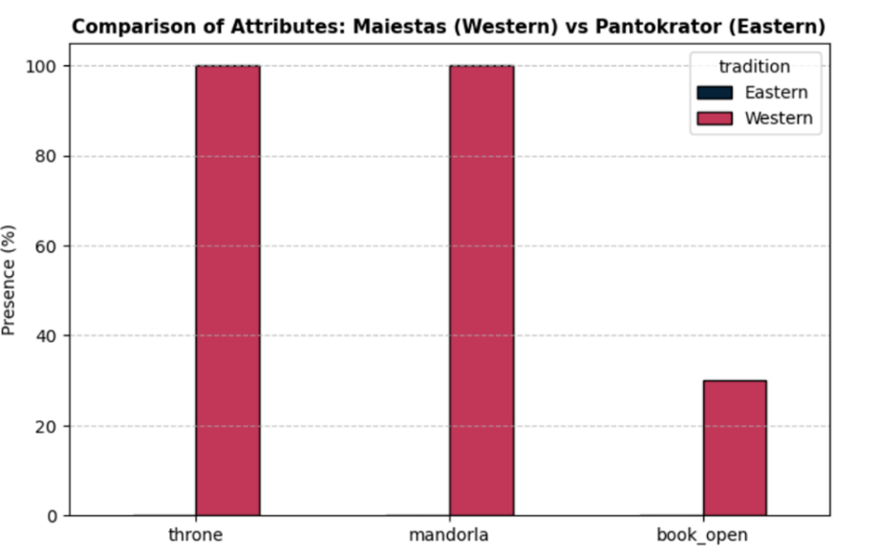

Figure 1: Attribute Comparison (Initial vs Extended Dataset)
This figure illustrates the change in the distribution of the “Open Book” attribute before and after the integration of the Samokov School dataset. It highlights how the inclusion of regional material contributes to a more nuanced representation of iconographic patterns within Orthodox art.

Orthodox iconography, particularly in the Balkan context, offers a compelling case for examining this dynamic. Preserved through long historical continuity and sustained liturgical practice, it represents a rich visual and theological tradition that is not always proportionally reflected in widely accessible datasets.
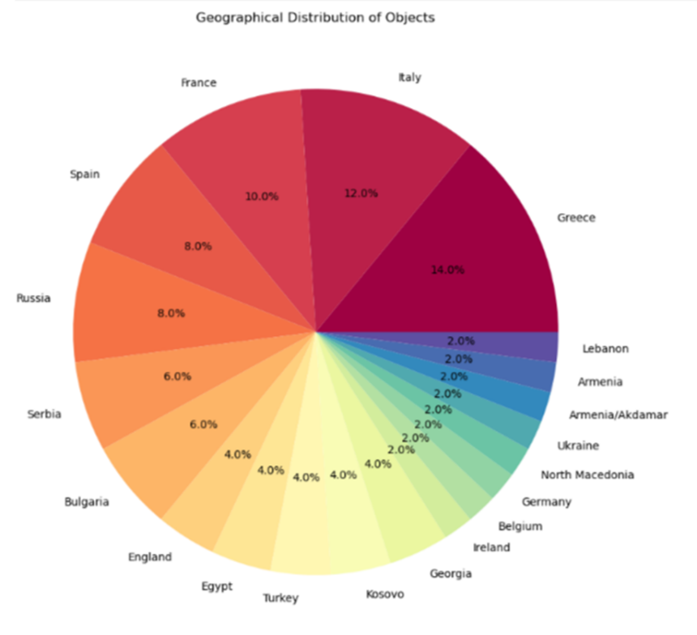

Figure 2: Geographical Distribution of Iconographic Attributes
This visualization presents the geographical distribution of artworks containing the “Open Book” attribute. It emphasizes the role of regional traditions, with a particular concentration observed in the Balkan cultural area following dataset expansion.

This study aims to explore how the inclusion of regional material—specifically from the Samokov Iconographic School—can contribute to a more nuanced and contextually grounded understanding of Christian imagery. By combining quantitative analysis with art historical interpretation, the paper seeks to demonstrate the value of integrating local knowledge into digital research environments.

2. Methodology

2.1 Dataset Construction
The initial dataset was compiled using publicly available information from major international collections and digital archives. Each artwork was annotated with a set of iconographic attributes, including the presence of the throne, mandorla, and open book, as well as metadata such as geographical origin, medium, and century.

2.2 Analytical Approach
The dataset was structured using Python and analyzed through statistical methods. Grouping by tradition (Eastern and Western) allowed for the calculation of the relative frequency of each attribute. Visualizations were generated to illustrate patterns across time, geography, and iconographic type.

2.3 Dataset Extension
To complement the initial dataset, a focused corpus of works from the Samokov Iconographic School was introduced, based on the author's doctoral research. This addition provided a regional perspective, enabling a comparative analysis before and after the integration of local material.

3. Results
The analysis of the initial dataset revealed distinct differences in the distribution of iconographic attributes between Eastern and Western traditions. In particular, the attribute of the open book appeared less frequently in the Eastern dataset, reflecting the composition of the available material.
Following the integration of the Samokov corpus, a noticeable shift emerged. The presence of the open book increased significantly within the Eastern tradition, highlighting the importance of theological emphasis on the Logos in the Balkan context.
Additional visualizations demonstrated the geographical concentration of this attribute, with Bulgaria appearing as a prominent contributor within the expanded corpus. Chronological analysis further emphasized the role of the 19th century as a period of renewed iconographic expression.
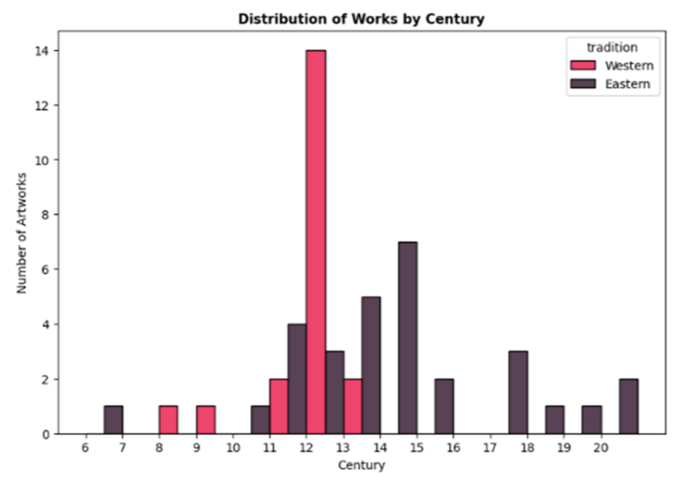

Figure 3: Chronological Distribution of the Dataset
This figure shows the temporal distribution of artworks across centuries, illustrating the increased density of 19th-century material introduced through the Samokov School corpus.

4. Discussion
The results of this study suggest that digital analysis in art history is closely linked to the representativeness of the underlying data. Patterns observed in global datasets may reflect not only historical realities, but also the structure and availability of digitized sources.
The inclusion of the Samokov School offers an example of how geographically specific material can provide additional depth to existing interpretations. Rather than challenging established knowledge, it contributes to a more layered understanding of Orthodox iconography, particularly in relation to theological symbolism and artistic continuity.
At the same time, the study acknowledges certain limitations. The dataset remains selective and does not claim to be exhaustive. Future research would benefit from the inclusion of additional regional archives and collaborative data-sharing initiatives.

5. Digital Enhancement and Computer Vision
In parallel with the statistical analysis, this project explores the application of computer vision techniques to the study of historical images. The use of Contrast Limited Adaptive Histogram Equalization (CLAHE) enables the enhancement of contrast in locally darkened areas, revealing details that may be difficult to perceive in the original image.
This method is particularly relevant for the analysis of Orthodox icons, where inscriptions and fine details are often obscured by the effects of time, varnish, and environmental conditions. By improving the visibility of such elements, CLAHE supports non-invasive approaches to digital preservation and paleographic interpretation.

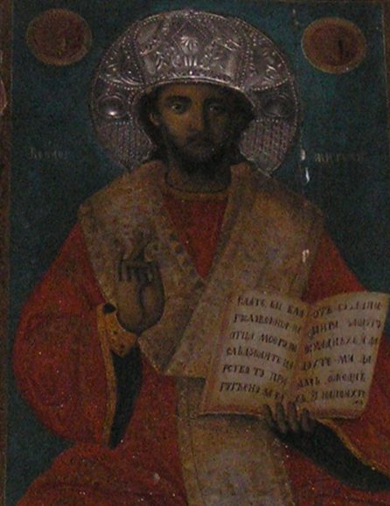
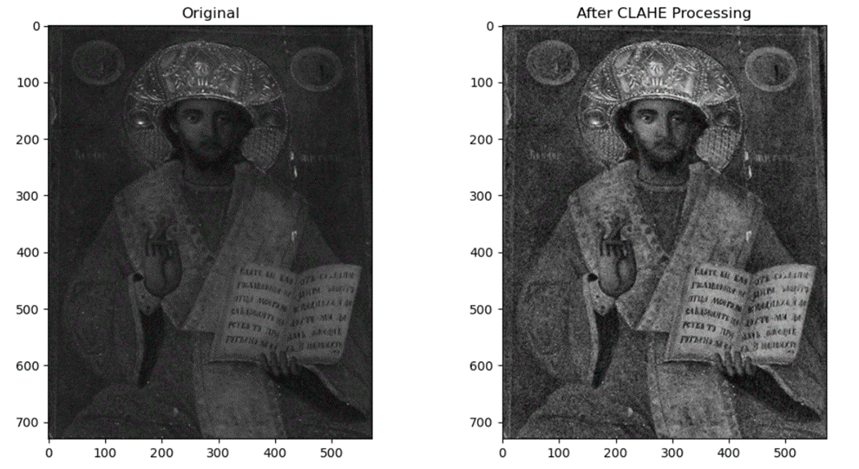

Figure 4: CLAHE Enhancement (Before and After)
This comparison demonstrates the effect of CLAHE-based image processing on a historical icon. The enhanced version reveals increased visibility of fine details and inscriptions that are less perceptible in the original image.

6. Conclusion
This study explored the intersection of Digital Humanities, Art History, and Computer Vision through the analysis of Orthodox iconography and the integration of regional cultural material into digital research environments.
The statistical observations presented in the dataset analysis reveal how the structure of available digital archives can influence broader interpretative patterns in the study of Christian imagery. The inclusion of geographically specific material from the Samokov Iconographic School provided an opportunity to examine how localized artistic traditions contribute additional historical and theological nuance within large-scale analytical frameworks.
At the same time, the application of CLAHE enhancement demonstrated the potential of computational image-processing methods for the non-invasive examination of visually degraded iconographic material. The improved readability of inscriptions and details suggests possible future applications in digital preservation, paleographic research, and the study of ecclesiastical art.
More broadly, the project illustrates the value of interdisciplinary collaboration between computational methodology and contextual art historical interpretation. As cultural heritage continues to enter the digital sphere, the relationship between global accessibility and regional specificity may become increasingly important for the creation of historically representative visual datasets.
Rather than replacing traditional scholarship, digital methods offer new ways of organizing, visualizing, and examining cultural material while remaining dependent on the interpretative depth provided by the humanities.

Bibliography & Digital Sources
Georgieva, Desislava S. (2006). The Samokov Painters in the Revival Churches of the Kyustendil Region. PhD Dissertation, National Academy of Arts, Sofia, 2006.
Klein & Gold (2016). Debates in the Digital Humanities
Zuiderveld (1994). CLAHE method
Manovich (2018–2022). AI aesthetics and visual culture

